“Kyiv Professional College of Communications”

Computer Engineering Cycle Commission

**PERFORMANCE REPORT**

**Work Case №2**

in the discipline: "Operating Systems"

Performed by students

RPZ-93B group

Team:

Бушовська О.В,

Білобровенко О.С.,

Скворцов Д.Є.

The teacher checked:

Сушанова В.С.

**Tasks:**

***Готував матеріал студент Скворцов Дмитро***

1. Install a Type II hypervisor on your home workstation - Virtual

Box, VMWare Workstation, Hyper-V (or another of your choice).

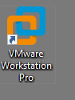

2. Describe a set of basic actions in the hypervisor you have installed:

● Creating a new virtual machine;

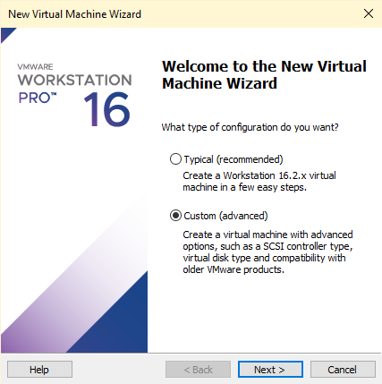

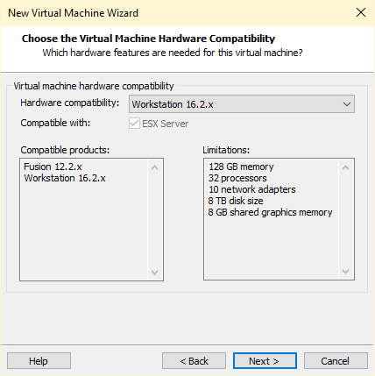

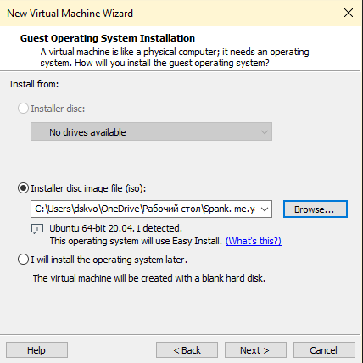

At this stage, you need to choose an image for our virtual machine

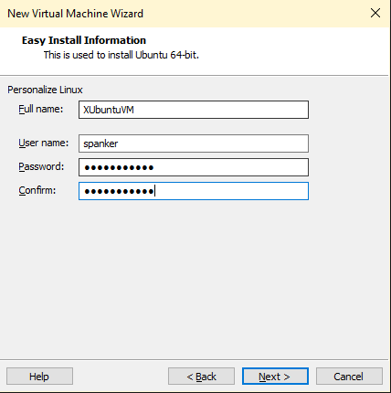

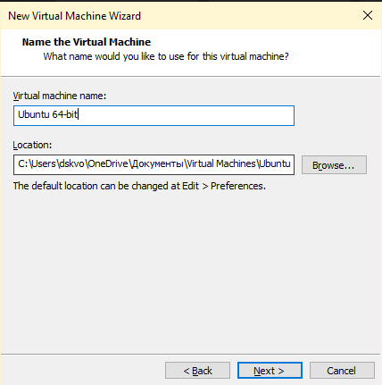

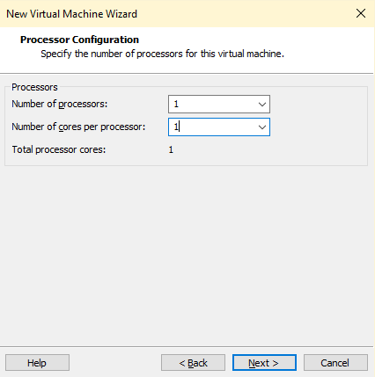

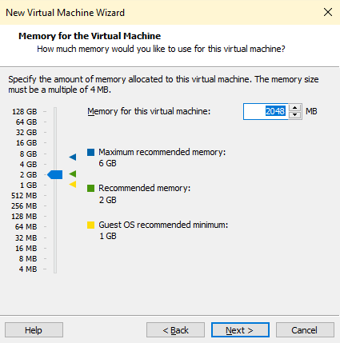

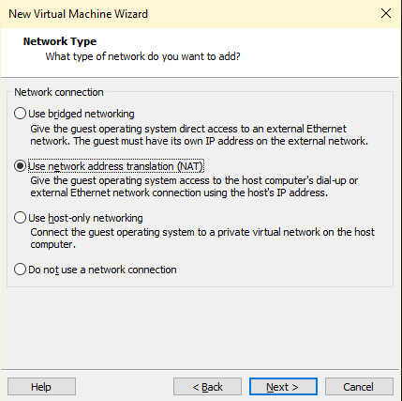

You should choose the network type.

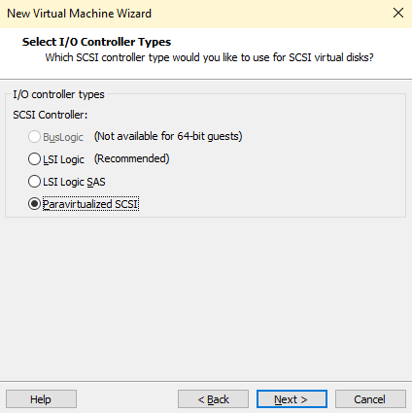

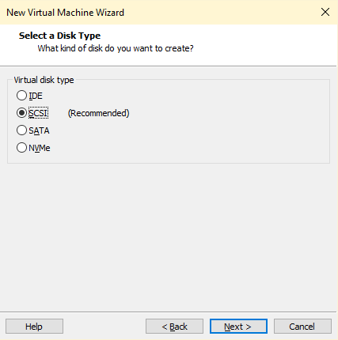

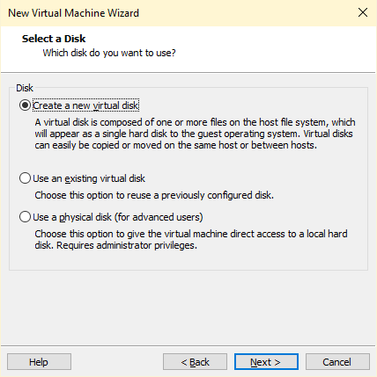

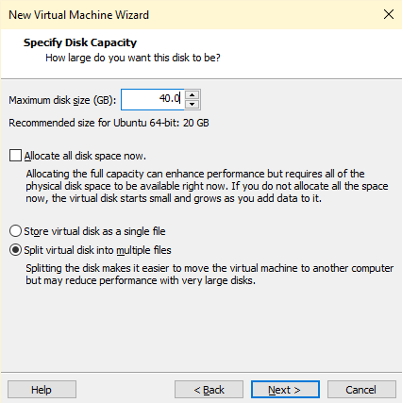

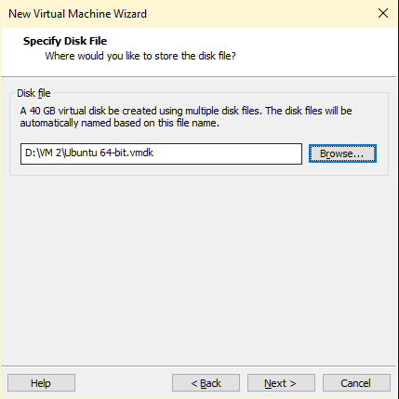

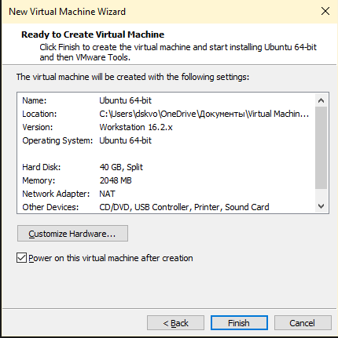

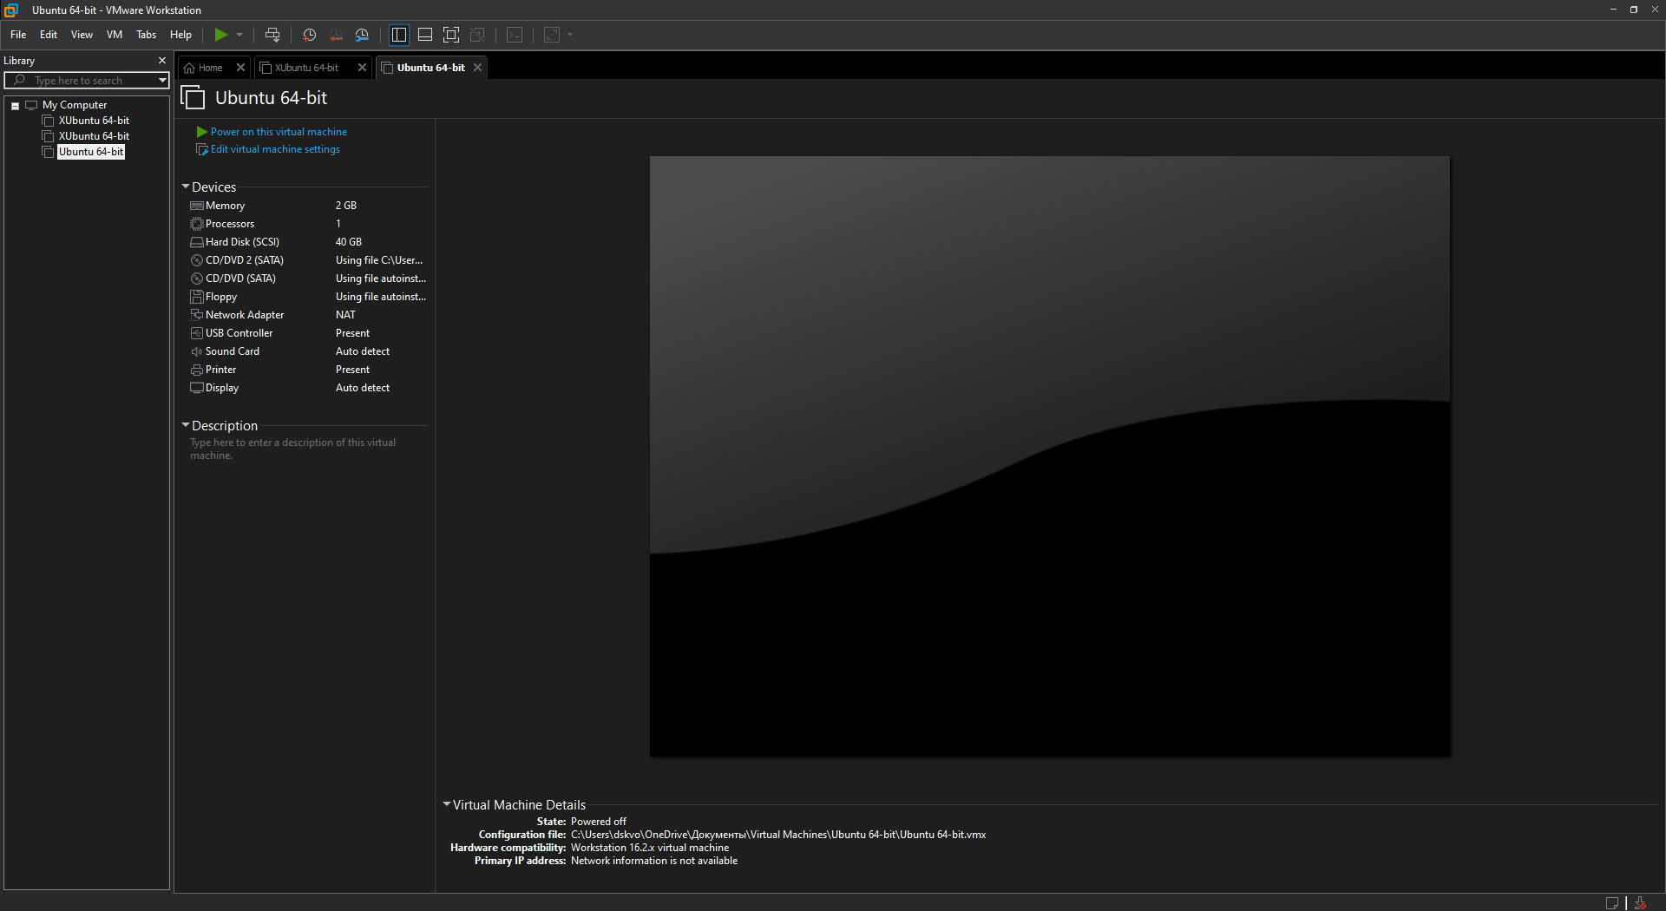

● Select / add equipment available for the virtual machine;

Workstation Player has been optimized for 4K UHD (3840 x 2160), QHD + (3200x1800) and x86 tablets.

● Network setup and Wi-Fi connection;

1) **Bridged/VMnet0.** In this connection, the virtual machine connects to the network using the host's physical network adapter. A virtual machine's virtual network adapter uses your computer's physical network adapter, allowing the virtual machine to access the same network as the physical computer. In other words, virtual machines get access to your local network. This type of connection is used most often.

***Готувала матеріал студентка Білобровенко Олександра***

2) **Host-only/VMnet1.** The second kind of network connects the guest virtual machine and the host computer, forming a private network. This connection provides a network connection between a virtual machine and a physical computer (host) using a virtual network adapter available to the host operating system.

With this type of connection, the virtual machine does not have access to the local network and the Internet. Because virtual machines do not have access to a physical network, VMware Workstation provides for the use of a DHCP service to assign TCP/IP settings to virtual machines.

***Готувала матеріал студентка Бушовська Ольга***

3) **NAT/VMnet8.** This is the third type of connection. This type of connection is characterized by the fact that the communication between the virtual machine and the host is carried out over a private network. Why is a second virtual network card installed in a physical computer.

When using a NAT connection, the virtual machine does not have its own external network IP address. However, the virtual machine can connect to computers from an external network using the standard TCP/IP protocol. In this case, the virtual machine uses the IP and MAC addresses of the physical computer.

It is worth noting that by default, a computer from the local physical network cannot connect to a virtual machine.

NAT connection is selected by default when creating a new VMware Workstation virtual machine.

***Готував матеріал студент Скворцов Дмитро***

● Ability to work with external media (flash memory).

Workstation Player takes advantage of the latest HD audio hardware with 7.1 surround sound, USB 3.0 devices, and Bluetooth technology to connect a webcam, headset, or printer to a virtual machine. In addition, Workstation Player improves the performance of Skype or Lync inside guest virtual machines.

3. Install the GNU / Linux CentOS operating system (or another convenient distribution) in the basic configuration with graphics shell.

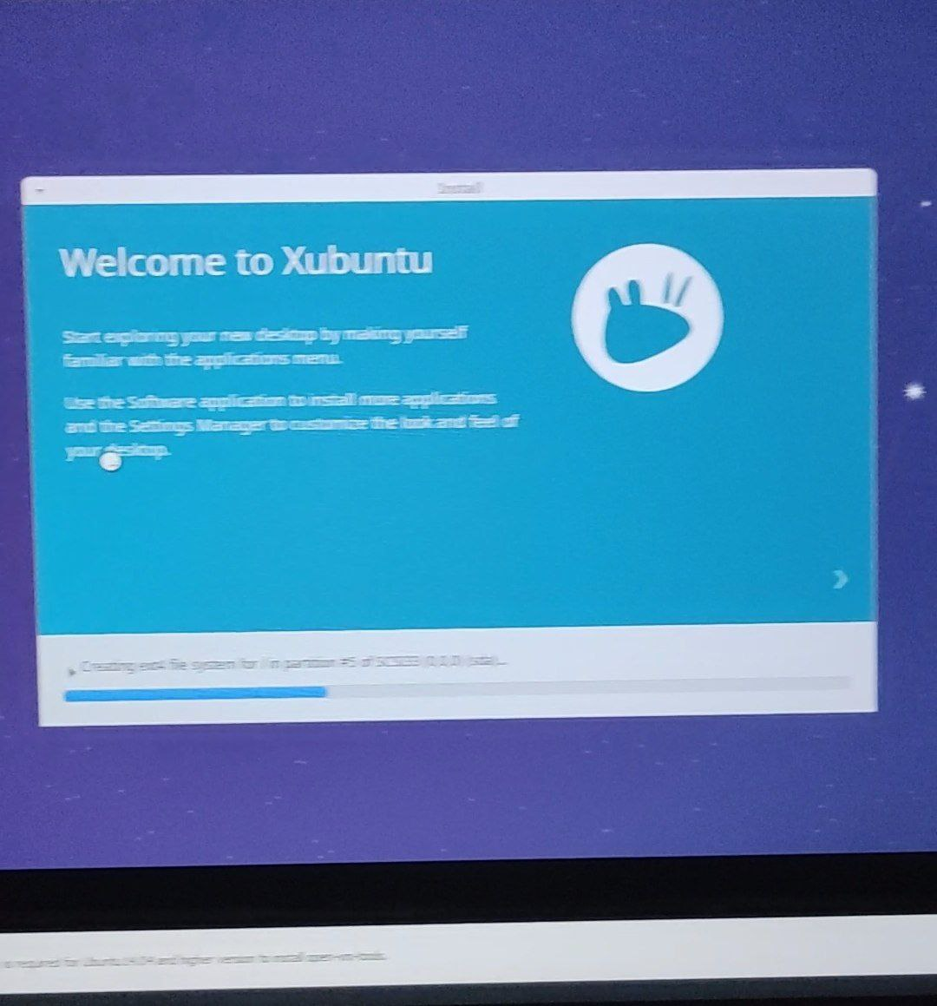

**Conclusion:** I learned a lot about hypervisors and virtual machines, and also learned how to install them.